**Domain Winter Camp DAY-7**

**Name :- Vikash Ranjan Kumar**

**Section/Group:-901-Kpit-B**

**UID :- 22BCS11322**

# Problem 1

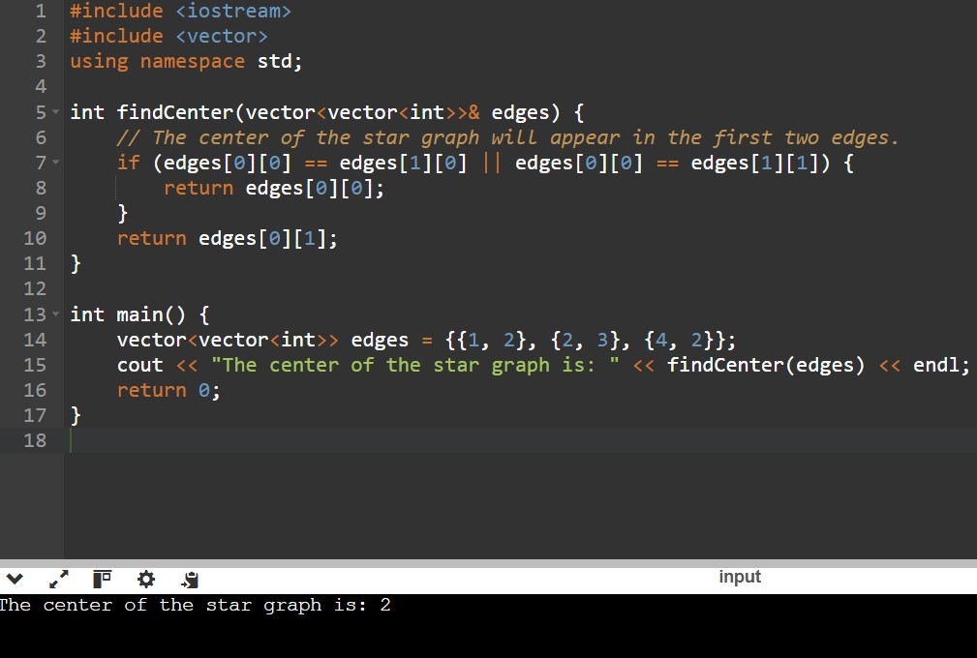

# Problem 2

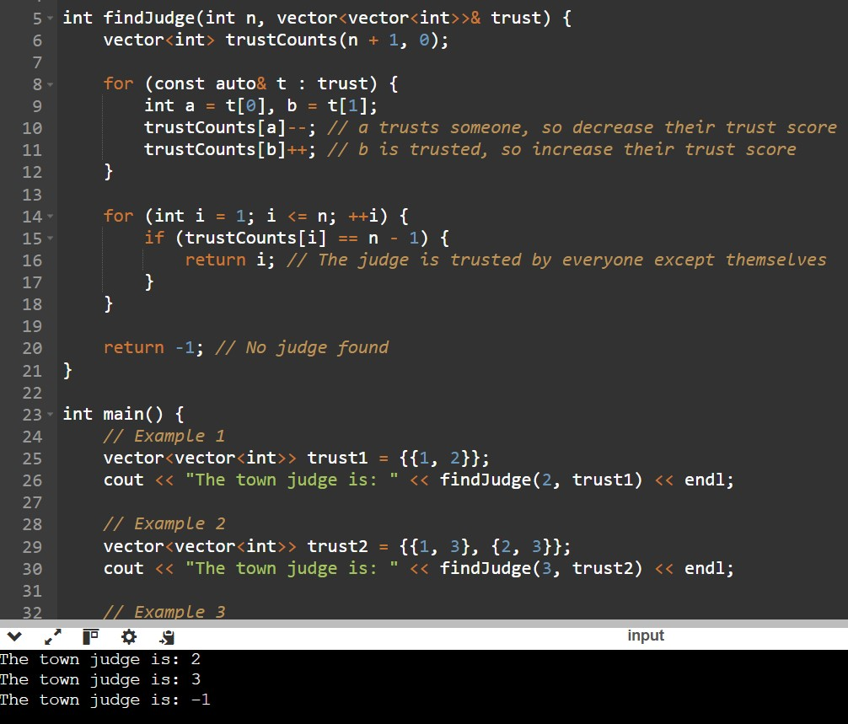

# Problem 3

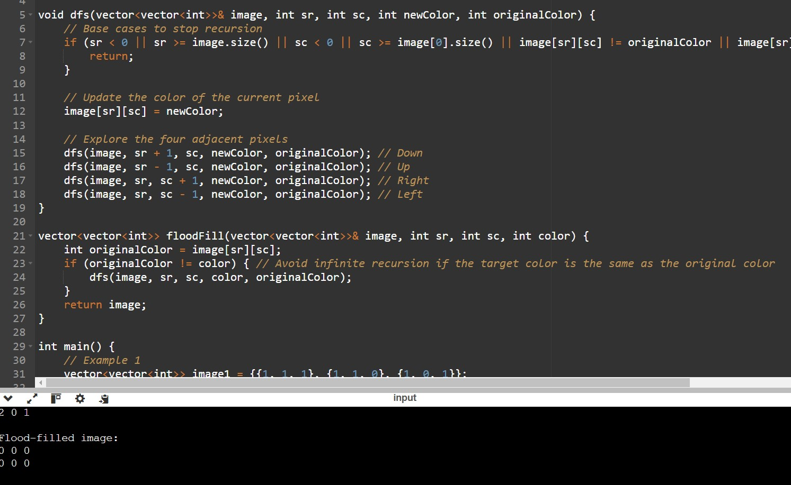

# Problem 4

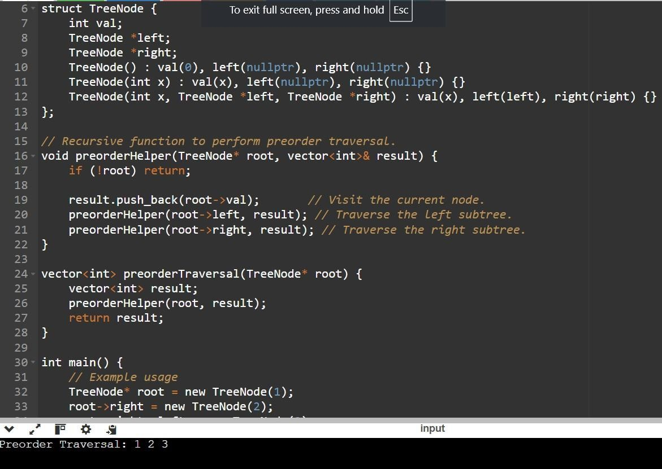

# Problem 5

